**Isomo Academy Student Transcript**

Bridge2Rwanda

KK 737 St, Kigali, Rwanda

**Student Name**: {{Name}}

**Date**: 09/22/2023

|  |  |
| --- | --- |
| **Year 1: Isomo Foundation Year | 2022** | **Grade** |
| Guided Reading | PASS |
| Communication Arts | PASS |
| Academic Writing | PASS |
| Language Lab | PASS |
| Innovation and Leadership | PASS |
| Mental Health Hour | PASS |
| Spiritual Formation | PASS |

|  |  |
| --- | --- |
| **Year 2: Isomo University | 2023** | **Grade** |
| Philosophy: A Brief History of Ideas | {{Philosophy}} |
| Research Capstone | {{Research}} |
| Climate Economy | {{Climate}} |
| African Literature | {{African}} |
| Innovative Leadership + Model Umushyikirano | {{Lead}} |
| Worldviews: A Survey of Global Perspectives | {{Worldviews}} |
| Experiencing Jesus | {{Jesus}} |

**Grade Point Average:** {{**GPA**}}

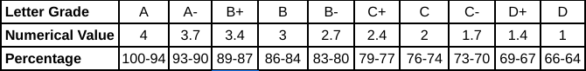

**Advisor**:

Luke Dreiling, Lead Teacher